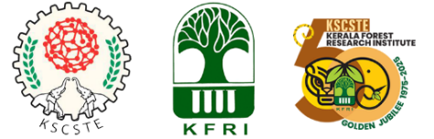
KSCSTE-Kerala Forest Research Institute
Culmination of Golden Jubilee (1975-2025) Celebration

TROPICAL FORESTRY CONCLAVE
(Hybrid Mode)

DECEMBER 15-19, 2025
KFRI, Peechi, Thrissur Kerala

REGISTRATION FORM
Full Name
Category |  | Student/ Professional
Institute/ Organization
Institution/Organization address
Country
Contact email
Contact whats app number
Contact Mobile number
Title of the abstract
Theme to which abstract is submitted (select one among the three subject themes to which your abstract is most suitable)- Refer Foot Note for themes
List of Authors (Corresponding author should be marked with *)
Fee payment details with transaction ID and date (Applicable for professionals only)
Mode of participation (Conclave will be conducted on a hybrid mode) |  | Offline/Online

Subject Themes
- Forest Biodiversity and Ecosystem Services | 15th December, 2025
- Forest Conservation and Management | 16th December, 2025
- Advanced Tools and Techniques in  Forestry research and Management | 17th December, 2025

Filled Registration form and abstract should be mailed to tfckfri@kfri.res.in

